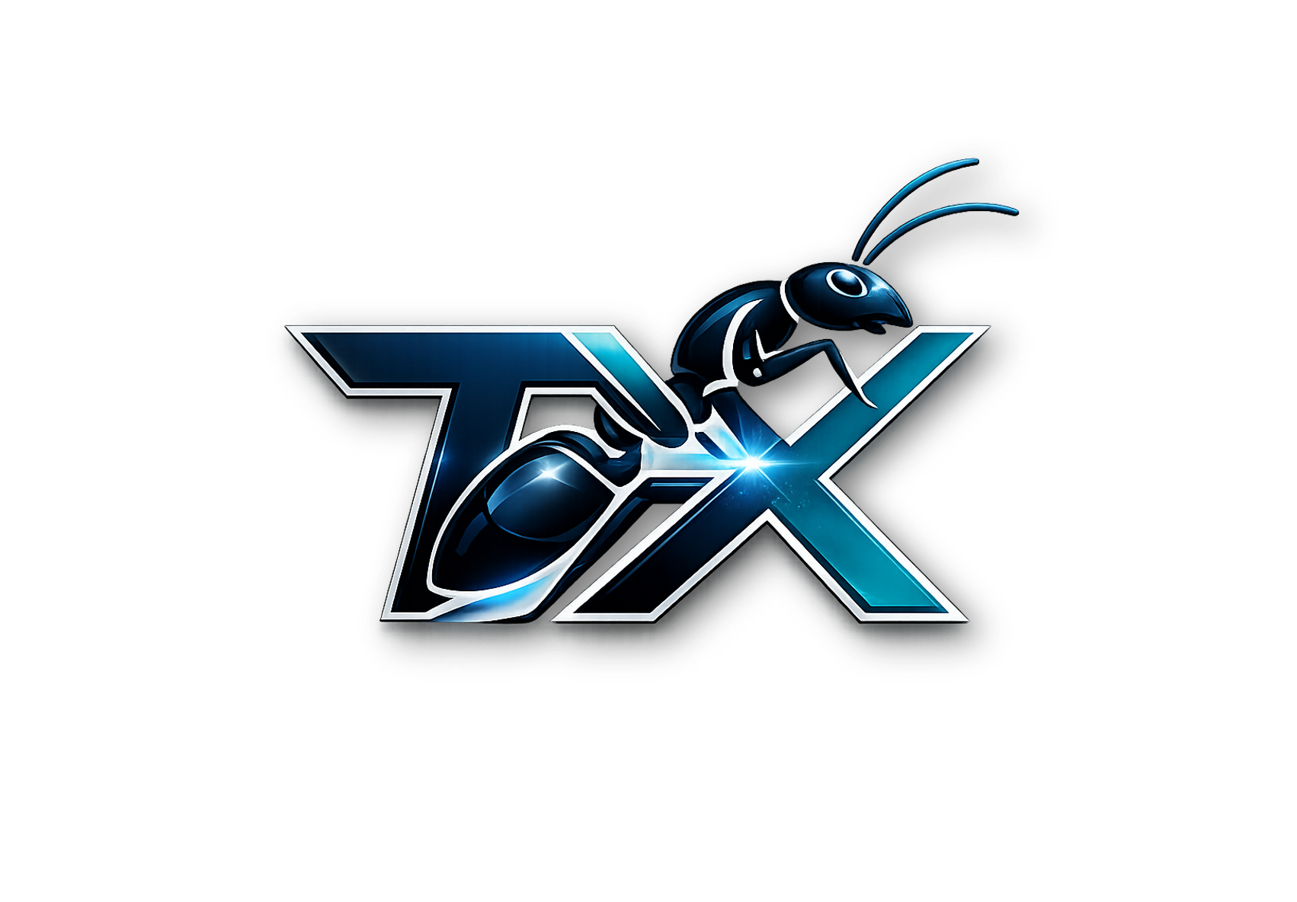

TX Wealth Creation Ecosystem — Business Plan
  - Education, enterprise enablement, verified commerce and responsible member tools
PREPARED FOR  TX Global Thinkers and Entrepreneurs | STATUS  Operational draft for review
DATE  September 2026 | VERSION  1.0

Executive summary
TX Wealth Creation Ecosystem is a Ghana-focused education and enterprise platform designed to help emerging entrepreneurs learn practical skills, develop market-ready businesses, access verified products and services, and track transparent member activity. The platform combines expert-led training, a digital member back office, an affiliate and partner store, business coaching, a five-level achievement journey, and a future Ant Susu savings experience delivered only through appropriately licensed partners.
The immediate commercial opportunity is to serve adults and early-stage entrepreneurs who need structured personal development, digital business skills, management capability, investment education, applied AI training and a trusted community marketplace. The model begins with genuine education and service revenue—not recruitment fees—and uses a compliance-first ledger to distinguish projected, pending, approved and paid activity.
Strategic proposition
Build a trusted learning-and-commerce ecosystem first; add regulated savings and payment functionality only after licensing analysis, partner due diligence, controls testing and legal approval.

Investment case
- Clear customer need: practical, accessible entrepreneurship and digital-skills development.
- Dual-currency presentation for USD pricing and disclosed GHS equivalents.
- Recurring engagement through quarterly training eligibility, courses, coaching and marketplace activity.
- Auditable member and administrator portals with referral attribution, board progress and earnings-status controls.
- Expandable B2C, B2B training, sponsorship-readiness and verified marketplace revenue streams.

1. Company and mission
Mission: empower the next generation of thinkers, leaders and entrepreneurs with skills, tools, networks and responsible pathways to create value. Vision: become a trusted African platform for practical learning, enterprise formation, transparent commerce and community advancement.

2. Problem and customer
Customer segment | Primary problem | TX response
Aspiring entrepreneurs | Limited structure, mentors and market access | Training, coaching and marketplace readiness
Micro and small businesses | Weak digital marketing and management systems | Practical courses, AI tools and business support
Young professionals | Need adaptable leadership and financial capability | Personal development and financial education
Institutions and employers | Need relevant workforce and entrepreneurship programs | Custom cohorts and expert-led seminars

3. Products and services
- Standard Membership — US$150 or disclosed GHS equivalent; optional US$50 monthly installments for three months.
- Combined Package — US$270 or disclosed GHS equivalent; positioned as the expanded recommended learning and enterprise-support offer.
- TX GRC-IntelliGuard — governance, risk, compliance and responsible technology training.
- Digital personal development, business and marketing, management, investment education, social development and applied AI training.
- Business idea coaching, creation support and sponsorship-readiness assessment.
- Verified affiliate and partner marketplace for products, services and member businesses.
- Future Ant Susu savings tools through a licensed financial or payment partner only.

4. Value proposition
Members receive an integrated journey from learning to execution: assess goals, complete practical training, build a business proposition, reach customers, document verified activity and monitor progress. The platform’s differentiator is the combination of local relevance, international expertise, structured member support and transparent status tracking.

5. Business model
Revenue stream | Timing | Control
Membership and course fees | Upfront/installment | Refund policy; clear deliverables
Advanced training cohorts | Quarterly or scheduled | Instructor and curriculum QA
Coaching and venture services | Project or package | Scope and milestone acceptance
Marketplace commissions | Per verified sale | Seller standards; refunds; fraud monitoring
Institutional training | Contracted | Signed scope; invoicing; outcomes
Sponsorship administration | If approved | Separate criteria; conflict controls

Excluded revenue logic
Recruitment alone does not create revenue or compensation. Member-fee recycling, guaranteed returns, unlicensed deposit-taking and unlicensed investment activity are prohibited design assumptions.

6. Go-to-market strategy
- Launch with the education and coaching offer; publish curricula, facilitator profiles and clear outcomes.
- Recruit pilot cohorts through universities, professional associations, SMEs, community groups and digital channels.
- Use demonstrations, free masterclasses and case studies to convert interested prospects.
- Build referral advocacy around course and service satisfaction, not income promises.
- Onboard verified partners only under written standards and disclosure rules.

7. Operations
Function | Core process | Owner
Learning | Curriculum review → enrollment → delivery → assessment | Program Director
Membership | Identity → package → payment evidence → activation | Member Operations
Commerce | Seller review → listing → order → fulfillment → support | Marketplace Lead
Earnings ledger | Evidence → review → approval → external settlement → paid status | Finance & Compliance
Technology | Release controls → monitoring → support → incident response | Technology Lead
Compliance | Legal classification → controls → audit → complaints | Compliance Lead

8. Technology roadmap
- Phase 1: member registration, referrals, boards, courses, benefits and controlled earnings ledger.
- Phase 2: content management, notifications, analytics, verified merchant catalog and support tickets.
- Phase 3: regulated payment integration, reconciliation, refunds and disclosed FX rates.
- Phase 4: Ant Susu partner integration, savings plans and withdrawals under licensed custody.
- Phase 5: institutional APIs, advanced reporting and regional expansion.

9. Compliance and risk
The Bank of Ghana’s Payment Systems and Services Act, 2019 (Act 987) provides the licensing framework for payment services; TX should use an approved provider and obtain legal advice before processing or holding funds. The Data Protection Commission regulates compliance with the Data Protection Act, 2012 (Act 843), including registration and responsible handling of personal data. Any investment-like product requires classification and engagement with the Securities and Exchange Commission. Cybersecurity governance should align with Ghana’s Cybersecurity Act, 2020 (Act 1038).
Risk | Impact | Mitigation
Misleading earnings claims | Regulatory and reputation harm | Approved claims library; monitoring; sanctions
Payment or savings misclassification | Severe legal exposure | Licensed partner; counsel; regulator engagement
Pyramid-scheme characteristics | Business-model failure | Retail-revenue tests; no recruitment-only rewards
Data breach | Member harm and penalties | Data minimization; encryption; access reviews; incident plan
Liquidity/refund failure | Customer harm | Separate accounts; reconciliation; reserve and refund rules
Partner misconduct | Brand and customer harm | Due diligence; contracts; monitoring; termination rights

10. Financial plan and assumptions
A complete financial model requires validated acquisition cost, course-delivery cost, staff plan, payment fees, refund rate, marketplace volume and retention data. The following management targets are planning assumptions—not forecasts or investment returns.
Measure | Pilot target | Year-one management target
Paying members | 50–100 | 500–1,000
Training completion | ≥70% | ≥75%
Refund/complaint rate | <5% | <3%
Retail/service revenue share | ≥70% of eligible revenue | ≥80%
Monthly reconciliation | 100% | 100%
Member-data incidents | 0 material incidents | 0 material incidents

Illustrative use of funds
Category | Indicative share
Product and technology | 25%
Curriculum and facilitators | 20%
Marketing and partnerships | 18%
Member operations and support | 15%
Compliance, legal and audit | 12%
Contingency and reserves | 10%

11. Milestones
- 0–90 days: legal classification, product/service catalog, policies, pilot curriculum, controls and partner shortlist.
- 3–6 months: education-only pilot, outcome measurement, complaint process and verified marketplace beta.
- 6–12 months: refine unit economics, institutional partnerships and regulated payment integration if approved.
- 12–24 months: scale cohorts and commerce; consider Ant Susu only after licensing and custody safeguards.

12. Governance
- Board or advisory oversight across education, finance, technology, compliance and community impact.
- Documented approval limits, conflicts register and related-party transaction rules.
- Monthly operating dashboard and quarterly compliance/risk review.
- Independent legal, financial and information-security reviews before regulated launches.

Sources and regulatory reference points
- Bank of Ghana — Payment Systems and Services Act, 2019 (Act 987): https://www.bog.gov.gh/wp-content/uploads/2022/03/Payment-Systems-and-Services-Act-2019-Act-987_.pdf
- Bank of Ghana — approved electronic money issuers and payment service providers: https://www.bog.gov.gh/news/list-of-approved-electronic-money-issuers-and-payment-service-providers/
- Ghana Data Protection Commission — compliance guidance: https://dataprotection.org.gh/compliance/
- Securities and Exchange Commission Ghana — public notices: https://sec.gov.gh/public-notices-press-releases/
- Cyber Security Authority Ghana: https://www.csa.gov.gh/

