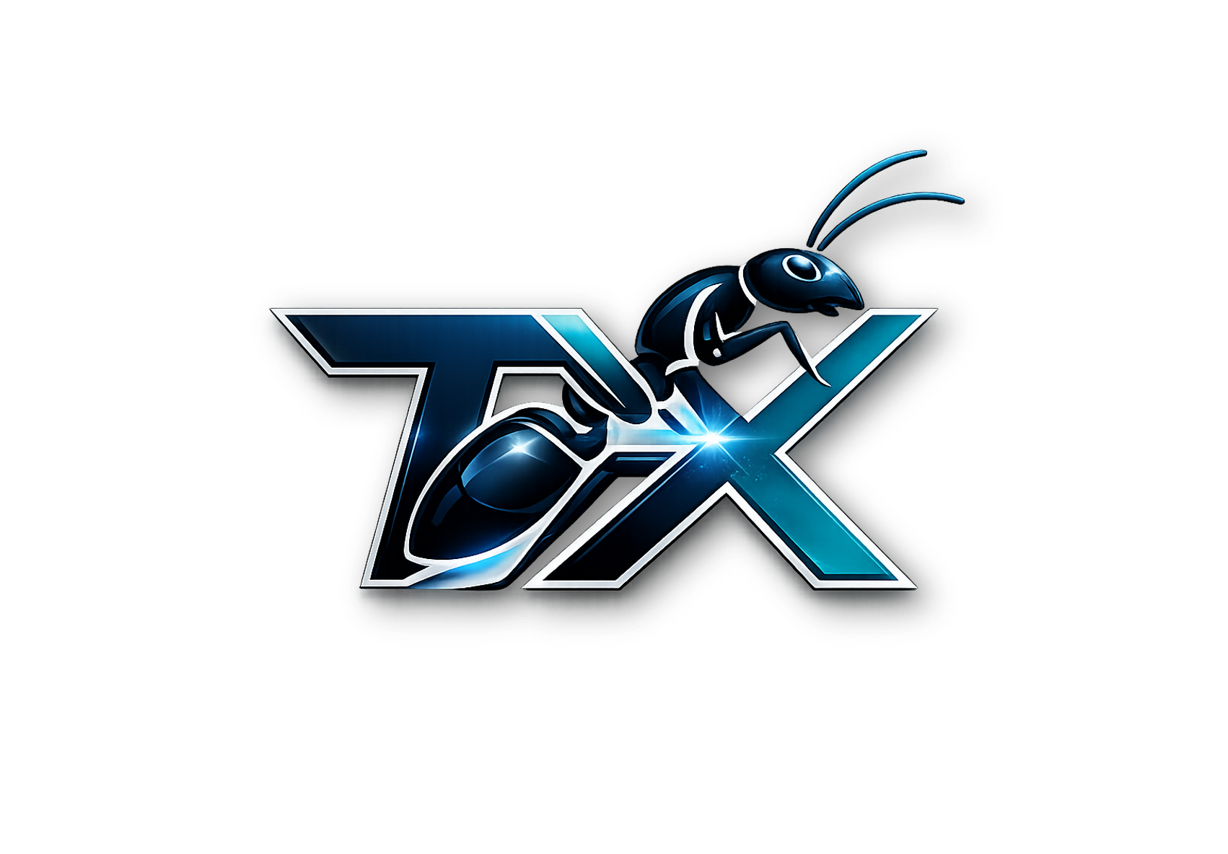
ANT WEALTH ECOSYSTEM

Compensation Plan Booklet
  - Building wealth through structured learning, commerce, savings and community advancement
CONFIRMED RULES AND PUBLIC TEST GUIDE
Updated 25 September 2026
Tink Xtra Enterprise, Ghana
IMPORTANT DISCLOSURE
This booklet describes proposed compensation mechanics supplied by TX Wealth. It is not an income guarantee, investment offer, tax opinion or authorization to collect deposits. Payments must be funded by lawful, verifiable product or service activity and launched only after professional legal, tax, regulatory and financial review.

1. Purpose and operating principles
The Ant Wealth Ecosystem combines member education, business development, verified commercial activity, board progression and a proposed flexible savings service. The compensation plan is designed to make every calculation visible before an administrator records an earning.
- No reward is guaranteed.
- Joining or sharing a link alone does not create an earning. Confirmed qualifying membership payments and approved board-cycle activity can generate test rewards under this plan.
- Every payable entry requires documented eligibility and administrator approval.
- Member savings must remain separate from operating cash and reward pools.
- Taxes, fees and withholding must follow applicable law and verified professional advice.
Marketing statement
The Ant Wealth Ecosystem offers 14 potential benefit and earning categories. Actual eligibility and payment depend on approved rules, verified activity, available revenue and applicable law.

2. Five-board structure
The lead allocation remains 80% of eligible board revenue after documented website/service operating costs and incoming collection fees. The original table below is retained as a zero-expense comparison; it is not a guaranteed payout or a new membership invoice.
Board | Members | Fee | Board value | Lead 80%
Ant Starter | 6 | $50.00 | $300.00 | $240.00
Ant Platinum | 14 | $100.00 | $1,400.00 | $1,120.00
Ant Gold | 30 | $200.00 | $6,000.00 | $4,800.00
Ant Diamond | 62 | $400.00 | $24,800.00 | $19,840.00
Ant Crown | 126 | $800.00 | $100,800.00 | $80,640.00

Progression: Ant Starter -> Ant Platinum -> Ant Gold -> Ant Diamond -> Ant Crown. After approved Crown completion, the next cycle starts at Starter with an increased cycle number. Administrators currently record and approve each board completion.

3. Deductions and illustrated net payouts
The supplied model applies a 0.5% processing and maintenance fee, a 10% government income-tax illustration, and a 30% next-board allocation on Boards 1-4. Crown has no next-board allocation.
Board | Lead | 0.5% fee | 10% tax* | 30% next board | Net
Ant Starter | $240.00 | $1.20 | $24.00 | $72.00 | $142.80
Ant Platinum | $1,120.00 | $5.60 | $112.00 | $336.00 | $666.40
Ant Gold | $4,800.00 | $24.00 | $480.00 | $1,440.00 | $2,856.00
Ant Diamond | $19,840.00 | $99.20 | $1,984.00 | $5,952.00 | $11,804.80
Ant Crown | $80,640.00 | $403.20 | $8,064.00 | $0.00 | $72,172.80

Tax note
The 10% line is a supplied planning assumption, not a legal tax determination. A qualified Ghana tax adviser must confirm the correct tax treatment, payer, base, withholding timing, reporting and member documentation before launch.

4. Downline earnings - five generations
The supplied illustration applies generation percentages to an eligible member's net board payout. These amounts are examples, not promises.
Board | Net payout | Gen 1 - 5% | Gen 2 - 4% | Gen 3 - 3% | Gen 4 - 2% | Gen 5 - 1%
Ant Starter | $142.80 | $7.14 | $5.71 | $4.28 | $2.86 | $1.43
Ant Platinum | $666.40 | $33.32 | $26.66 | $19.99 | $13.33 | $6.66
Ant Gold | $2,856.00 | $142.80 | $114.24 | $85.68 | $57.12 | $28.56
Ant Diamond | $11,804.80 | $590.24 | $472.19 | $354.14 | $236.10 | $118.05
Ant Crown | $72,172.80 | $3,608.64 | $2,886.91 | $2,165.18 | $1,443.46 | $721.73

5. Fourteen earning and benefit categories
01 Board Earnings
Cycle. 80% of the eligible board base after operating and collection costs; then apply the existing plan deductions. This is the board lead allocation, not a combined 80% pool for all categories.
02 Downline Earnings
5 generations. Illustrated 5%, 4%, 3%, 2% and 1% of eligible net board earnings.
03 Sponsor Bonus
Weekly. Illustrated 5% of qualifying member fee or eligible activity.
04 Indirect Bonus
Weekly / up to 10 generations. 1% TOTAL of qualifying activity shared equally across eligible active generations, not 1% per generation. Missing or inactive positions do not move other generations forward.
05 Payment Bonuses
Weekly. Illustrated sponsor 2% and beneficiary 1% allocations.
06 Leadership Bonus
Monthly. A 3% pool of the eligible monthly membership-fee base, shared equally among active members with an approved Crown completion. Crown qualification does not expire.
07 Global Performance Pool
Quarterly. A 2% pool of the eligible quarterly membership-fee base, shared equally among active members with an approved Crown completion. Crown qualification does not expire.
08 Cash Back
Quarterly. Illustrated 1% of qualifying fees paid.
09 Widow Support Fund
Social impact. Illustrated 2% allocation for approved community support.
10 Training Fund
Social impact. Illustrated 2% allocation for education and workshops.
11 Travelling Fund
Social impact. Illustrated 2% allocation for approved development travel.
12 Board Fund
Sustainability. Illustrated 3% allocation supporting board administration.
13 Ant Susu Savings
Flexible. Member savings feature, subject to regulated provider integration.
14 Cycle Earnings
Repeat cycles. Completing Crown allows a new Starter cycle. A restart does not create a second award for the same completed board.

6. Bonus formulas and timing
Category | Timing | Supplied illustration
Sponsor Bonus | Weekly | 5% x qualifying member fee or approved activity base
Indirect Bonus | Weekly | 1% TOTAL x qualifying activity, shared equally across eligible active generations up to 10
Payment Bonuses | Weekly | Sponsor 2%; beneficiary 1% of defined eligible base
Leadership Bonus | Monthly | 3% x eligible monthly fees, equally shared by active Crown-qualified members
Global Performance Pool | Quarterly | 2% x eligible quarterly fees, equally shared by active Crown-qualified members
Cash Back | Quarterly | 1% x qualifying fees paid
Widow Support Fund | Ongoing | 2% x defined eligible membership-fee base
Training Fund | Ongoing | 2% x defined eligible membership-fee base
Travelling Fund | Ongoing | 2% x defined eligible membership-fee base
Board Fund | Ongoing | 3% x defined eligible membership-fee base

Funding control
Before activation, the organization must prove that all bonus and fund allocations can be paid from lawful earned revenue without recycling new-member payments or member savings.

7. Ant Susu savings
The proposed Ant Susu feature allows members to set daily, weekly or monthly savings plans, view transaction history and request withdrawals. A proposed 0.5% maintenance fee must be disclosed before confirmation.
- Use a properly licensed custody, banking or payment partner.
- Show the fee amount, net deposit, withdrawal timing and any limits before confirmation.
- Keep savings funds segregated from operating and compensation accounts.
- Provide statements, reconciliation, complaints handling, identity checks and fraud controls.
- Do not describe savings as yielding a return unless a regulated product expressly supports it.

8. Member dashboard and earning lifecycle
Every potential earning should move through a visible status workflow:
Status | Meaning | Member expectation
Projected | Planning illustration | Not payable and not guaranteed
Pending | Evidence submitted or activity recorded | Awaiting verification
Approved | Eligibility and amount authorized | Scheduled under payment controls
Paid | Disbursement completed and recorded | Receipt and ledger entry available

Use the member portal to review recorded status and activity. Current amounts are simulations. Paid means a recorded test settlement, not a bank transfer. USD and GHS displays for an earning represent the same earning and cannot be withdrawn twice.

9. Eligibility and administration
- A valid member account with completed identity and contact information.
- An active membership status under published rules.
- Verifiable eligible product, service, course or approved program activity.
- No duplicate, self-funded, fictitious or manipulated transactions.
- No payment before required cooling-off, refund or chargeback windows close.
- Administrator review with an auditable decision record.

Administrator controls
Authorized administrators may review evidence, approve or reject activity, change board status after verified completion, record deductions, schedule payments, reverse erroneous entries and export audit reports. High-value approvals should require dual authorization.

10. Marketing and member communications
Approved headline: 'The Ant Wealth Ecosystem offers 14 potential ways to benefit and earn.'
Do not say
Guaranteed income; risk-free earnings; automatic profit; everyone gets paid; recruit two and earn forever; government-approved unless documented; or any fixed tax claim not confirmed by a qualified adviser.

Do say
Potential earnings depend on eligibility, verified activity, approved rules, earned revenue, fees, taxes and applicable law. Member savings are not used to pay another member's reward.

11. Pre-launch approval checklist
- Obtain Ghana legal advice on direct selling, consumer protection, securities, payments, data protection and tax.
- Confirm the legal entity, contracts, refund policy, privacy notice and complaints process.
- Complete a revenue-coverage model and independent compensation-plan review.
- Contract with appropriately licensed payments and savings providers.
- Run a simulated-money pilot and reconcile every ledger path.
- Approve marketing claims, training materials and administrator access controls.
- Publish final eligibility, deductions, tax treatment, payout calendar and change-notice rules.

12. Final statement
TX Wealth intends to support learning, enterprise development, disciplined savings and community advancement. The compensation plan can only be sustainable when customer value, earned revenue, transparent controls and member protection come before recruitment volume. This booklet should be adopted only after qualified professional review and formal organizational approval.
Document status: Owner-confirmed compensation rules for the public test system at https://wealth.tinkextra.com, updated 25 September 2026. Live payments and payouts are not enabled. Professional review remains necessary before a real-money launch.

13 Confirmed rules for the public test

Cost and fee treatment
Deduct documented operating and incoming collection costs before the 80% board lead allocation. Do not subtract collection costs twice if the receipt is already net. Apply the existing 0.5% plan processing fee, 10% tax illustration and 30% next-board allocation on Boards 1 to 4 to the lead amount. Crown has no next-board allocation. The 10% line is an unverified planning assumption, not a statement of the applicable tax rate.

Board example with operating costs
For a synthetic Starter board revenue of USD 300 and documented operating/collection costs of USD 20, the eligible base is USD 280. The 80% lead is USD 224. Illustrative deductions are USD 1.12 processing, USD 22.40 tax and USD 67.20 next-board allocation, leaving USD 133.28. The original USD 142.80 table result assumes zero operating/collection costs.

Member paid payout fees
For a future live withdrawal, the member pays the actual bank or provider payout fee. Show the amount, actual fee and net payout before confirmation. Do not charge the plan processing fee again if it was already deducted from the earning. Current test withdrawals use a simulated zero provider fee.

Approvals and schedules
Weekly draft generation runs after the completed week; monthly and quarterly drafts use completed UTC calendar periods. These schedules generate drafts only. Administrators still review and approve them. Duplicate source rewards are blocked. A pending record is not payable; an approved earmarked fund is never a personal earning.

Equal shares and qualification
Indirect, leadership and global pools use equal shares. Remaining cents are assigned by ascending member number. Leadership/global recipients must have an approved fifth-board Crown completion and be active when calculated; no new Crown completion is required each period. This is not a promise of lifetime payments.

Current capability boundary
Items 2 to 12 have test calculations and review workflows; item 13 has simulated savings; item 14 has sequential administrator-attested cycle records. This is not a fully automatic board placement system. Provider payouts, real savings custody, a full buy/sell marketplace and external affiliate-provider integrations are not available. Do not collect real money in this test.

